BSNL Introduces Broadband TOP UPs for High Speed Internet after FUP in Unlimited Plans

BSNL Unlimited Internet Broadband Customers can enjoy New DATA TOP UPs to get High Bandwidth (Download Speed) after FUP Limit…

Just think, that when one fine day you want to have video call to dear ones and at that point if your data limit is exhausted with FUP limit of Unlimited Broadband Plan, and even if you are ready to pay for Broadband Data Top-up, still being a BSNL, you may be thinking that you have to wait for next billing cycle to regain your speed.

To overcome this instance, BSNL comes with a Good News for BSNL high data usage Broadband consumers by providing DATA Top-Ups for you with in your billing cycle after crossing the data limit for the month.

Now the scenario is going to change, being a State Owned and Largest Broadband Subscriber base Telecom Operator, which needs to have stringent approvals, still daily you are able to see the pace how BSNL is wooing you… with the best offers you have never thought from BSNL.

BSNL has decided to serve to you more and wants to bring happiness for their Broadband Customers, just by allowing you take extra data within existing cycle with a very nominal charge. BSNL CMD A.N.Rai inaugurated new facility of Broadband TOP UP to restore the original speed for BSNL Broadband Unlimited Plans.

The charges for additional data purchase within the billing cycle will be very low as indicated below. For Rs.100/200/300/500 you can get additional 2GB/5GB/10GB/20GB. Just go to the Top-Up and enjoy you extra usage at a very nominal cost…. love being BSNL customer.

Broadband TOP UP Data Charges | Extra Usage Offered
Rs. 100 | 2 GB
Rs. 200 | 5 GB
Rs. 300 | 10 GB
Rs. 500 | 20 GB

Ok, you might be having a doubt, how to check whether my Broadband FUP (Fair Usage Policy) has reached and when I have to go for data top-up. There is no problem, after your limit crossed, BSNL is going to prompt you by a pop-up and its up to you to go ahead, if you want to enjoy with existing speed, then just ignore it, or else go for Broadband Top-Up. The extra amount will be charged to you in next bill accordingly.

This new introduction of Broadband TOP UPs for restoration of Higher Speed Internet after FUP limit in BSNL Unlimited Broadband Plans, will helps all the high data usage customers involved with more internet centric applications, to do their works at any time with out any inconvenience caused, at affordable & cheapest rates, and this new Broadband TOPUPs will be applicable for all New & Existing Broadband customers of all the Circles across India.

For example:
If your current BB plan is “BB Home Combo ULD 999”
Speed 4Mbps till 8 GB beyond 512 Kbps
After crossing 8GB usage you will get like below message

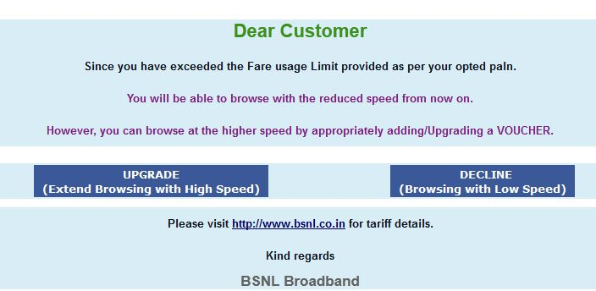

You can click "UPGRADE" AND CHOOSE
· Rs.100 : to get current speed of 4Mbps up to another 2GB
·Rs.200 : to get current speed 4Mbps up to another 5GB
·Rs.300 : to get current speed 4Mbps up to another 10GB
·Rs.500 : to get current speed 4Mbps up to another 20GB

If you donot want this upgrade SIMPLY CLICK “DECLINE".
It will continue to work in reduced speed of 512kbps till the end of the month.

Courtesy: Tanjore SSA / TNC

