GTI Related guidelines for processing in payroll of February 2026
With reference to BSNL Corporate Office Establishment Section letter F. No. BSNL CO-A/11(11)/2/2022-ESTB dated 06.02.2026, it is informed that the Group Term Insurance (GTI) premium shall be deducted from the salary of February 2026.
Separate lists of Executives and Non-Executives, indicating employees who have opted for the GTI scheme, shall be provided by the Corporate Office after closure of the scheme.
Circles are advised to carefully verify the correctness of the list. It may be noted that once the GTI premium is deducted from salary, the amount will be remitted by BSNL Corporate Office to the insurer, and no refund shall be permissible under any circumstances after deduction.

1. Data for creation of GTI premium deduction in IT0057 should be uploaded through following procedure.
The GTI premium deduction shall be created in Infotype 0057 using the following procedure:
T-code: ZHRTC_BDC_57

Steps to be followed:
(a) Preparation of Excel File
Prepare the Excel sheet in the following format:
PERNR | AMOUNT | SUBTYPE | ENDATE
60150017 | 9440 | GTIL | 28022026
Important instructions:
- Do not include column headers while uploading.
- The Amount and End Date must not contain decimals.
- The End Date must be exactly 28022026 for all employees.
- There should not be spaces in any of the field.
(b) File Conversion
- Copy the data (without header) and paste it into Notepad.
- Save the file on the desktop in .txt format.
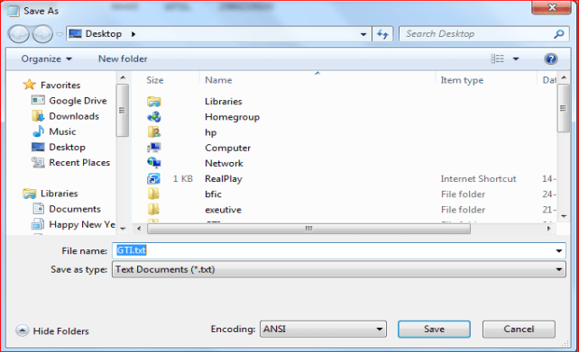

After saving following is visible at desktop


(c) Uploading the File
Run Tcode ZHRTC_BDC_57, the following screen will appear and user have to fill the following data as shown below:-

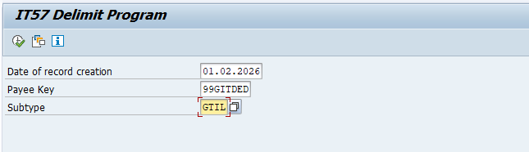

Now Click on Execute button and upload the GTI txt file from saved location, the following screen will appear, click on YES tab:-

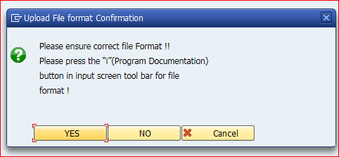
Then following screen will appear:-
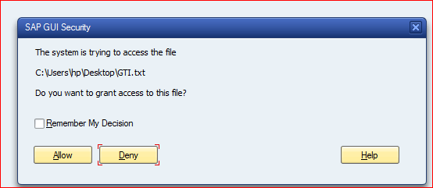

Click on allow, then following screen will appear:-
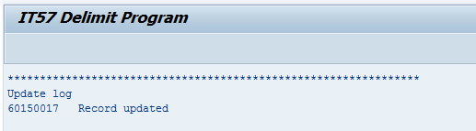

(d) Verification
• Verify the uploaded data in IT0057 for all concerned personnel numbers.
• Cross-check the uploaded records using T-code ZHRTR_PAY_KEY.

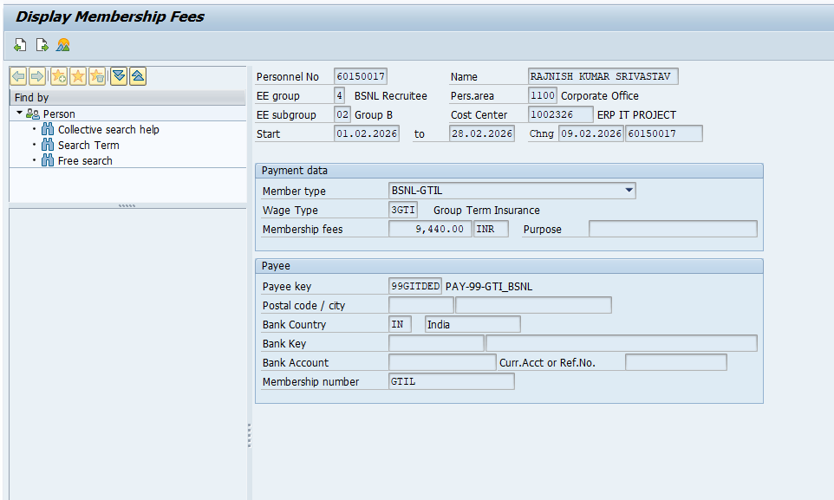

Important Note:
The End Date must invariably be 28022026. If any other end date is entered, the system will continue deducting GTI premium in subsequent months, and refund of excess deduction will not be possible from the HCM module.

2. Employees on Deputation / PND / Zero Salary / Transferred but Not Joined Cases
For employees who:
- Are on deputation,
- Are under PND,
- Are zero salary cases, or
- Have been relieved but not joined at the new station (thus payroll processing for February 2026 is not feasible),
and have opted for GTI as per the list provided by Corporate Office, the GTI premium shall be recovered through Cash / Cheque / Bank Transfer.

Accounting Procedure:
- Cash/Cheque:
Post through T-code FBCJ under Business Transaction “COLL FOR GTI PREMIUM”.
- Bank Transfer:
Post through T-code FB50 by:
  - Debiting the Incoming Collection GL in which the amount is deposited, and
  - Crediting GL 1310204 – Payable: Group Term Insurance (GTI).
Mandatory Instructions:
- Ensure that the Personnel Number is captured correctly in the ‘Assignment’ and ‘Pers. No.’ fields in both FBCJ and FB50.
- Enter the full premium amount.
- Tax codes must not be used.

3. Maintenance of Deduction under Section 80C
The BA/SSA DDOs / Circle Payroll DDOs shall maintain the GTI premium details in IT0586 (80C deduction) only for those employees who have paid the GTI premium through Cash / Cheque / Bank Transfer.
This provision is applicable exclusively to employees who have opted for the Old Tax Regime.

4. Transfer of Balance to LIC Vendor
After finalization of payroll, the Circles shall transfer the duly reconciled balance lying in GL 1310204 : Payable-Group Term Insurance (amounts posted through Payroll, FBCJ, and FB50) to LIC Vendor Code 100086135.
- Document Type: KR
- T-code: F-04
- The process shall be followed in the same manner as transfer of take-home salary.

5. Submission of GTI Schedule to Corporate Office
After payroll finalization, the GTI recovery schedule shall be emailed to the Core Team at:
- prashantgupta@bsnl.co.in
- carajnishsrivastav@bsnl.co.in
Timeline:
On or before the morning of 26.02.2026
Format to be followed:
S. No. | PERNR | Name | Payroll Area | Amount | Mode of Recovery (FI/Payroll) | Document No. (if FI)
1 | 1002801 | Sachin Tanwar | 1100 | 9440 | Payroll | Payroll
2 | 60150017 | Rajnish | 1100 | 9440 | FI | FBCJ / FB50 Doc. No.

