**Entry of already Issued Desktop/Laptop data in ERP System**

1. Use T-Code PA30 and fill the Pernr of the officer to whom Desktop/Laptop is already issued.(as shown below):

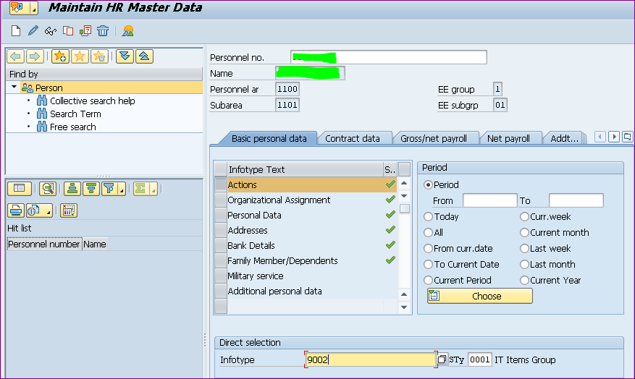

**Create the record.**

**Fill Pernr of the officer**

**Fill Infotype & Subtype as shown**

1. After clicking on creation button the following screen will appear:

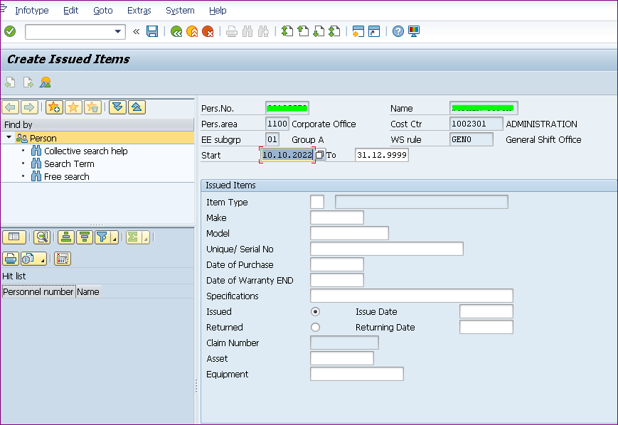

Kindly fill the required data in the respective filed and click on “Save” button, the record will be created.